Getting to Know God:

What do you think was Paul’s main point to the church of Corinth about not acknowledging sin in the sight of God in this week’s sermon?

Why would God judge His House first, “The House of God,” before He judges the world concerning Judgement?

What did I learn this week that I can put to use in my own life?

My life Group Prayer Needs:

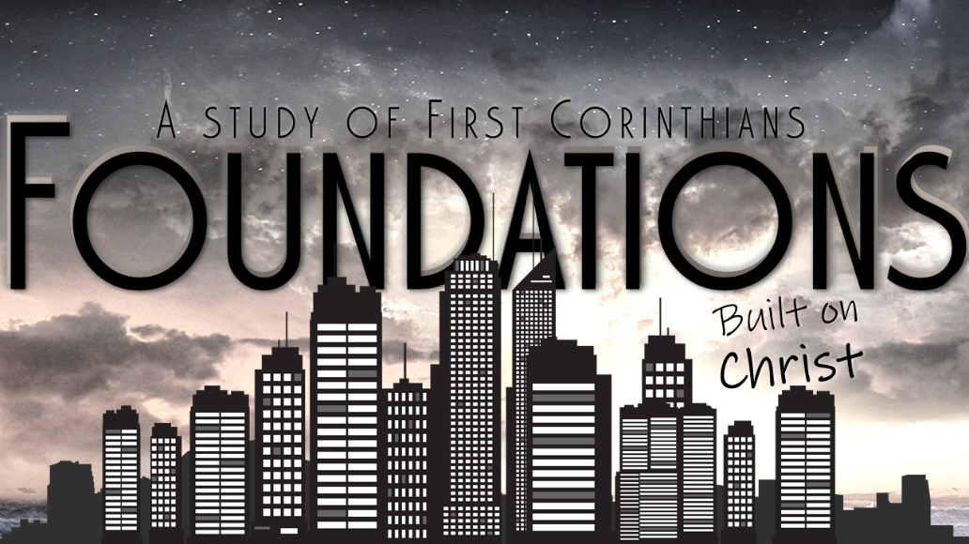

“What Should We Do, Church?” 1 Corinthians 5:1-13
Message Notes: Week of 10/31-11/6/21

In 1 Cor 5:1-13, The apostle Paul is writing to the Church of Corinth, about the dangers of letting sins, such as sexual immorality go unchecked, without dealing without the church dealing with it.

What should we do about sin in the church?
- We should acknowledge it
- We should take action
- We should use church discipline

Getting to Know One Another:

What are the dangers of allowing sin to go unchecked within the church body when the body knows about it? Give examples.

When should the church judge, and not judge? Please explain.

Getting to Know the Word:

What are some of key takeaways from this week’s Sermon in 1 Corinthians 5:1-13? Please explain.

In 1 Corinthians 5:7, why do you think Paul mentioned the importance of purging out the leaven in reference to The Passover in the Old Testament?

In 1 Corinthians 5:5, why the importance of delivering an un- repentant member of the body over to Satan?

