Getting to Know God:

In Romans 6:23, Paul contrasts the differences between choosing sin and choosing God. How does God’s gift reveal the nature of God?

Read Romans 8:26-28. How do these verses reveal the nature of God? How does God use bad for good?

My Life Group Prayer Needs:

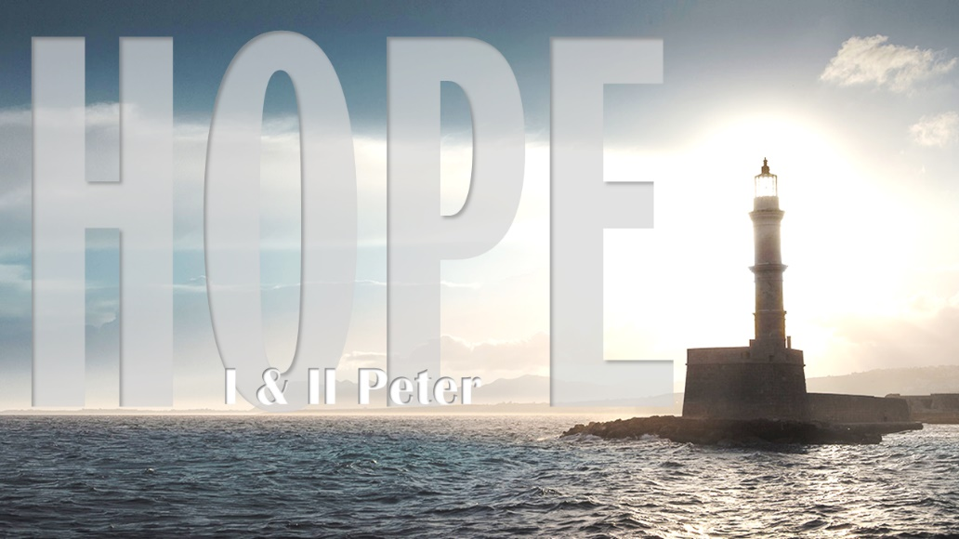

“We See in a Mirror Dimly” 1 Peter 4:12-19

Message Notes: Week of 8/7/2022

This week, we will be looking at suffering for Christ and our faith. We will be looking at how we can put them into perspective…

Peter is trying to get his readers to think about their persecution. Peter is trying to get his readers to understand why they are being persecuted…

An important thing to realize is that this idea of suffering is another way we can identify with Christ, essentially being on the same team…

Getting to Know One Another:

Have you ever experienced some suffering? Have you ever been through some tough times?

How is suffering an identifier with Christ?

Getting to Know the Word:

Read John 15:18-19. What are some ways God calls us to be separate from the world.

Read 1 Peter 5:10. How does this verse bring you comfort? How is it encouraging for you?

